Task 2 Supplementary Architecture Notes
Distributed EV Charging Navigation System
This document supplements the presentation by enlarging the architecture diagrams and recording the assumptions needed to interpret them. The design models 64 charging nodes and four base stations on a cluster. MPI carries inter-process messages, while OpenMP accelerates each base station's local candidate search.
Logical topology | 8 by 8 non-periodic mesh with direct logical-neighbour communication
Parallel model | 64 single-threaded node ranks; four base ranks with four OpenMP threads each
Deployment | Four 32-core hosts; 20 active cores per host; 80 active cores overall
Communication | Point-to-point operational protocol; Bcast for setup and Barrier for round completion

Design scope
- The threshold, number of rounds, mesh dimensions and update frequency are user-configurable.
- Logical adjacency is independent of physical rank placement. The regular mesh is a reproducible simulation baseline.
- Charging ports remain local objects inside a charging-node process and do not create extra MPI ranks.

Static software structure
The diagram identifies every required simulation component and separates distributed processes from local state.
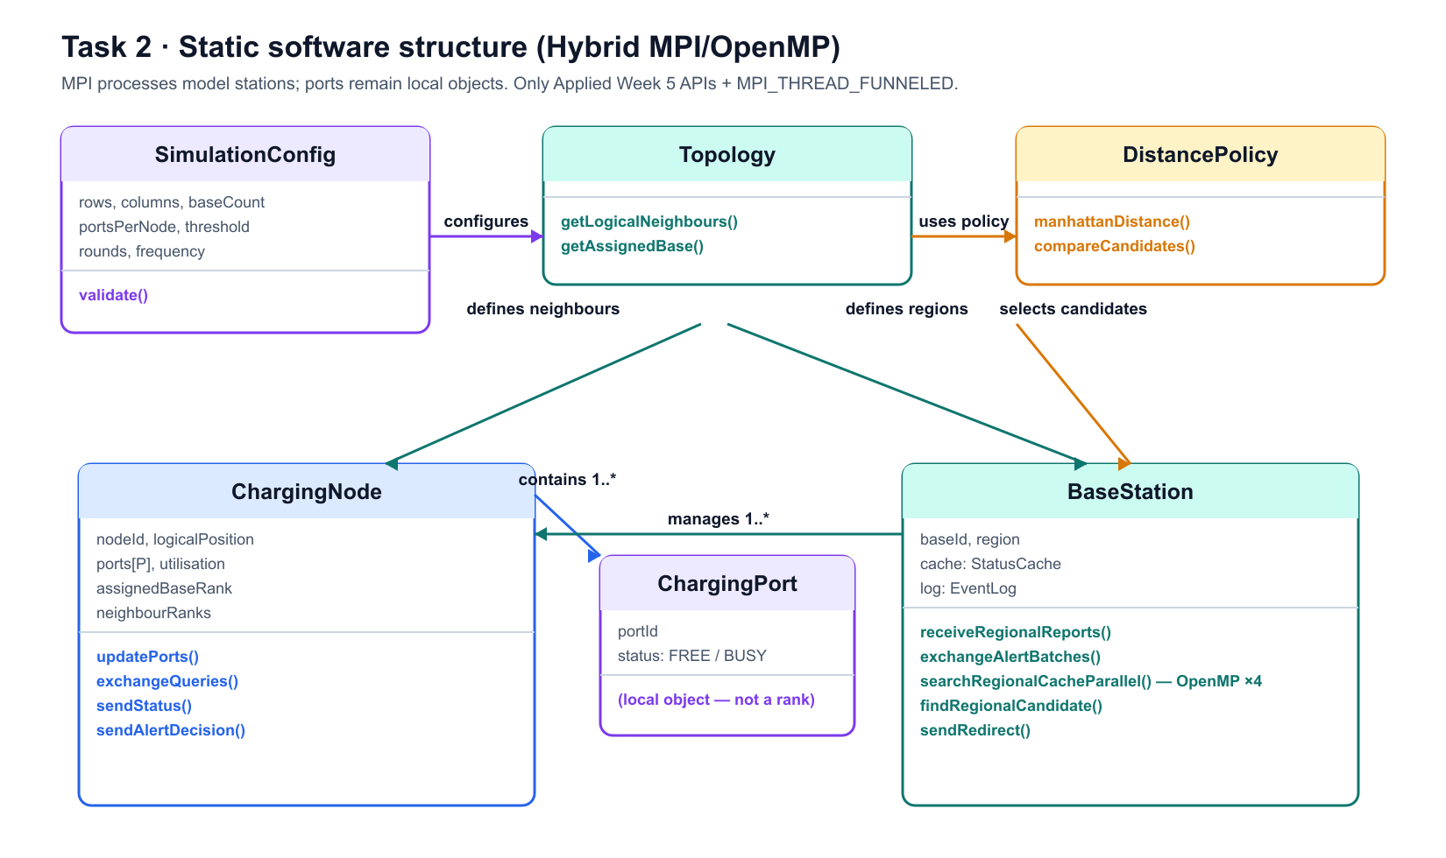
- ChargingNode and BaseStation are MPI processes. ChargingPort remains local state inside ChargingNode.
- Four OpenMP threads search disjoint cache partitions; the master thread merges their results.
- DistancePolicy can replace logical Manhattan distance with road distance or travel time.

Communication sequence for one round
Every phase has a known completion rule. Fixed query-intent records and count-before-batch exchange prevent indefinite receives.
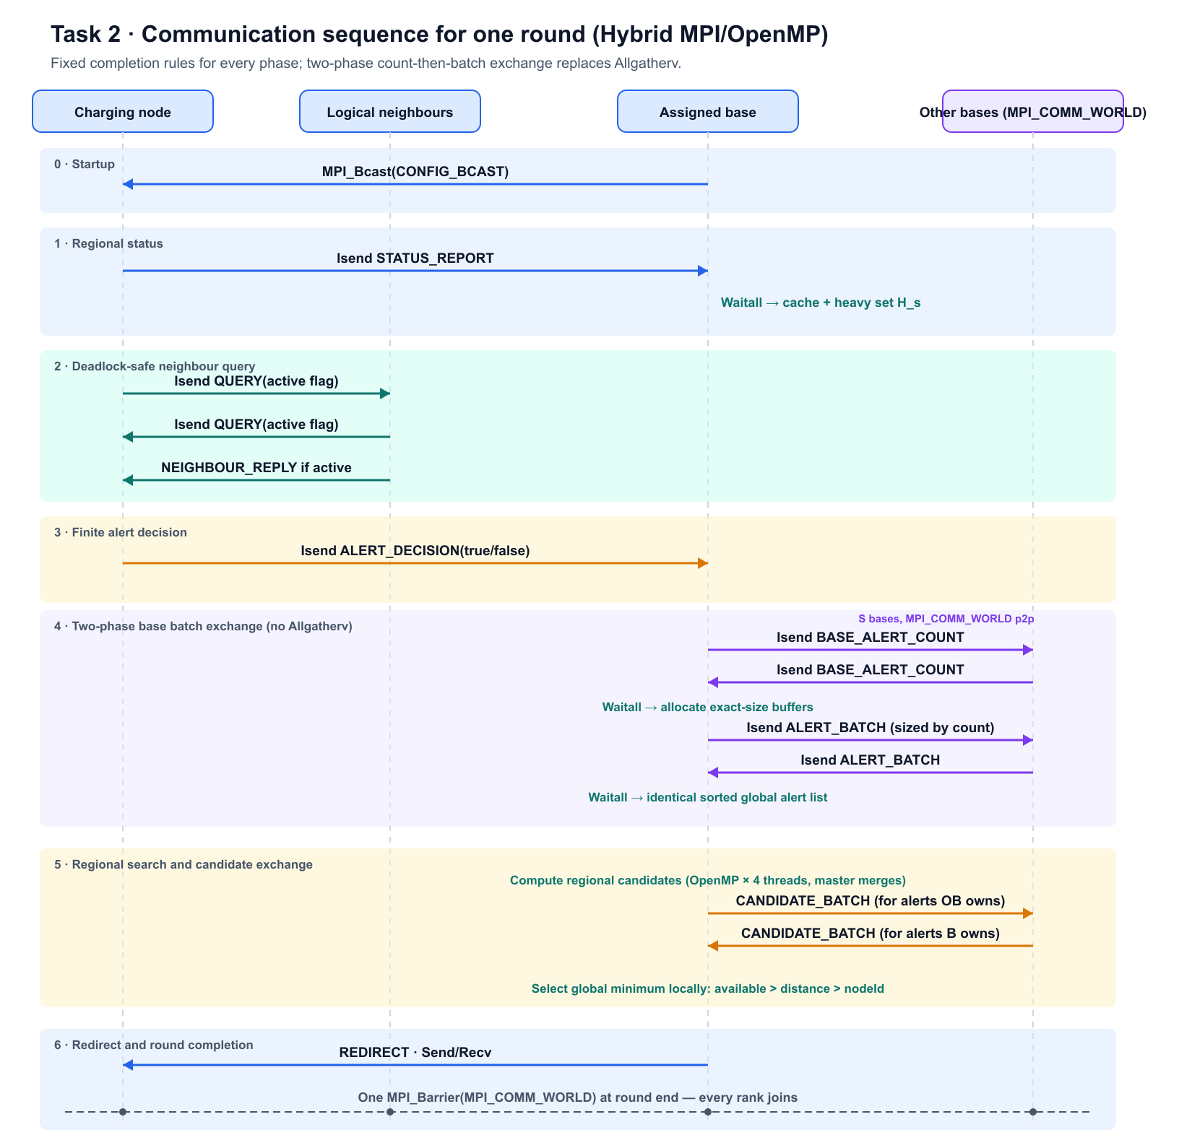
Only active query records request neighbour data. ALERT_DECISION(true) is the specification-level alert; false records complete the phase without creating an alert. OpenMP performs local cache search before the master thread exchanges candidate batches.

Rank layout and cluster deployment
Ranks share MPI_COMM_WORLD. Rank arithmetic creates the logical mesh; physical placement groups each region with its assigned base.
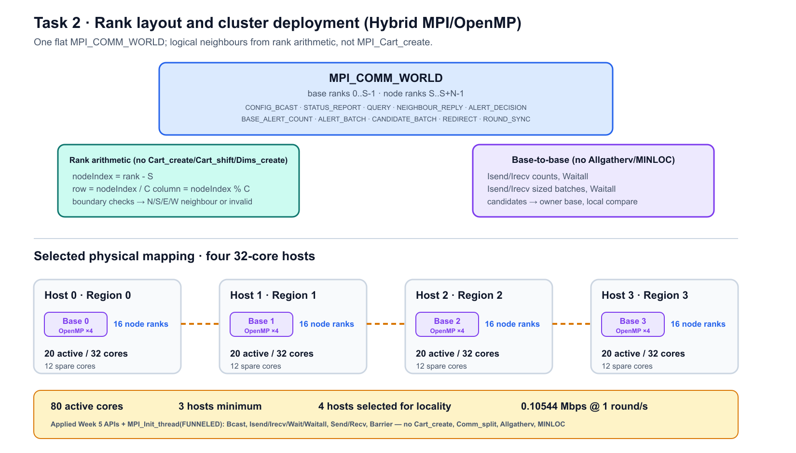
- For nodeIndex = rank - S: row = nodeIndex / C and column = nodeIndex % C. Boundary checks return up to four valid neighbours.
- Each OpenMP team contains four total threads, including the master thread. MPI is initialised with MPI_THREAD_FUNNELED.

Message catalogue and sizing
Payload sizes are analytical assumptions and exclude MPI and lower-level network headers. Task 3 uses the same catalogue.
Message | Direction | Payload | MPI operation | Per-round scaling
CONFIG_BCAST | base 0 to all | 64 B | Bcast | startup only
STATUS_REPORT | node to assigned base | 32 B | Isend/Irecv/Waitall | N
QUERY | node to neighbour | 16 B | Isend/Irecv/Waitall | 2E_mesh
NEIGHBOUR_REPLY | neighbour to active node | 24 B | Isend/Irecv/Waitall | up to 2E_mesh
ALERT_DECISION | heavy node to base | 32 B | Isend/Irecv/Waitall | H; A true
BASE_ALERT_COUNT | each base to other bases | 4 B | Isend/Irecv/Waitall | S(S-1)
ALERT_BATCH | each base to other bases | 32 B/alert | Isend/Irecv/Waitall | A(S-1)
CANDIDATE_BATCH | base to alert owner | 16 B/item | Isend/Irecv/Waitall | A(S-1)
REDIRECT | owner base to source node | 24 B | Send/Recv | up to A
ROUND_SYNC | all ranks | 0 B | Barrier | once

Correctness and bandwidth
Receives are posted before matching sends, non-blocking requests complete before buffer reuse, distinct tags separate message classes, and round identifiers reject stale records. OpenMP workers access local memory only; the master thread performs MPI calls under MPI_THREAD_FUNNELED.
For the four-host worst case with A = N = 64, external payload is 10,544 bytes per round: 1,280 bytes of cross-region neighbour traffic, 48 bytes of alert counts, 6,144 bytes of alert batches and 3,072 bytes of candidate batches. At one round per second with a 25 percent allowance, required aggregate bandwidth is 1.25 x 8 x 10,544 = 0.10544 Mbps.
Limitations and future work. The baseline assumes reliable MPI ranks and uses logical Manhattan distance. Process-failure handling and a real road or travel-time distance source remain future extensions.

